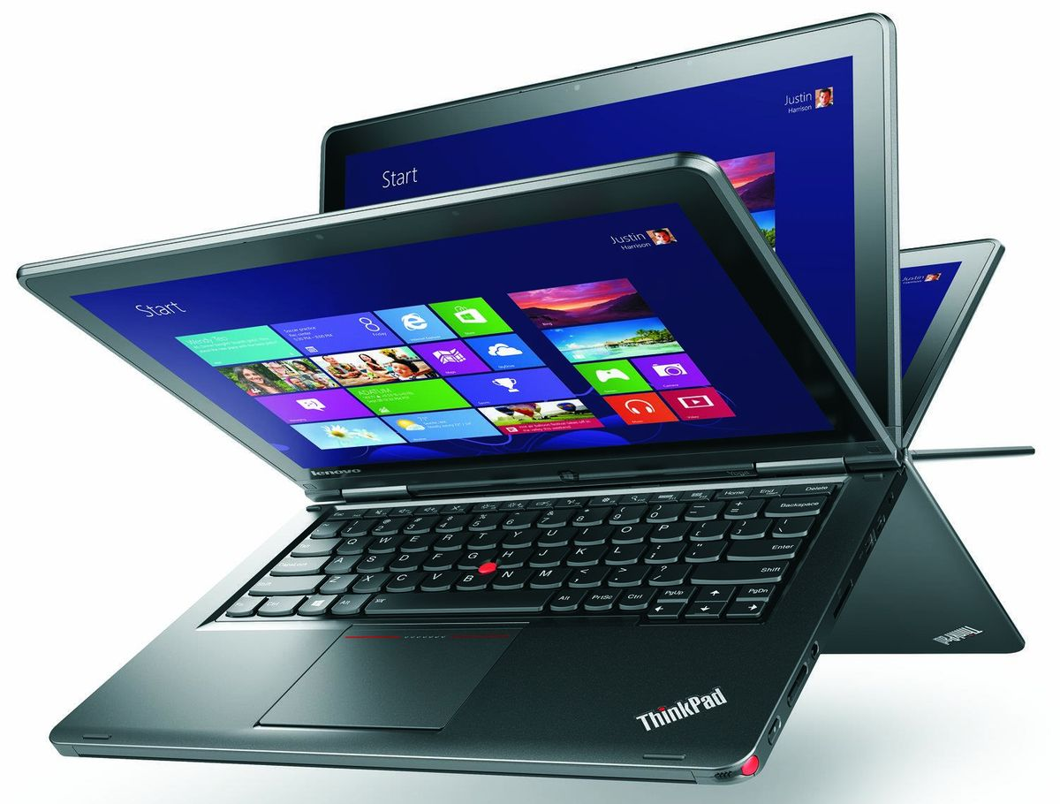

Laptop Usage

Web Cams
Purpose
Each student laptop is equipped with a web cam. This equipment offers students an extraordinary opportunity to experience a 21st Century tool and to develop 21st Century communication skills.

Examples of Use
Web cams are to be used for educational purposes only, under the direction of a teacher. Examples include:
- Recording videos or taking pictures to include in a project
- Recording a student giving a speech and playing it back for rehearsal and improvement.

Listening to Music
At School
Listening to music on your laptop is not allowed during school hours without permission from the teacher. Permission will be given only for media used to complete a school assignment.

At Home
Listening to music on your laptop (for example, from a streaming website) is allowed at home with permission from parents/guardians.

Watching movies
At School
Watching movies on your laptop is not allowed during school hours without permission from the teacher. Permission will be given only for media used to complete a school assignment

At Home
Watching movies on your laptop is allowed at home with permission from parents/guardians.

Gaming
At School
Online gaming is not allowed during school hours unless you have been given permission by a teacher. Any games must be in support of education.

At Home
Online gaming is allowed at home if all of the following conditions are met:
- The content of the game is school appropriate
- You have permission from your parent/guardian
- The game is in support of education
- All school work is complete
- No download of any kind is needed

You are not allowed to load personal software onto your computer.

Printing
Printing at School
Any documents that require printing should be printed at school. This means there should be no school-required reason for printing at home. If a student chooses to print school work at home, we suggest using the following options:
- Save the file on a thumb/flash drive and use the home computer to print.
- Email the file to the student’s Outlook email account. Use the home computer to access the web-based Outlook, and print from the home computer.
Printing at Home
Printer drivers can be installed on the school laptop. BSD Service Center provides limited support for personal/home equipment

Care of Laptops at School
- Lock the computer before walking away from it
- Follow all directions given by the teacher

Care of Laptops at Home
- Laptops should be stored in their case
- Charge the laptop fully each night, after use so that it is ready for classroom use
- Use the laptop in a common room of the house
- Store the laptop on a desk or table; never on the floor
- Protect the laptop from extreme heat or cold, food and drinks, small children, pets
- Keep the laptop clean and free of stickers or other decorations
(Clean laptops with a soft damp cloth when the laptop is powered off)

Traveling with the Laptop
- Completely shut down the laptop before traveling
- Do not leave the laptop unattended in a vehicle
- If you are ever in a situation when someone threatens you for your laptop, give it to them and tell a District staff member as soon as you get to school.

Prohibited Actions
Students are prohibited from:
- Students may not loan laptop components to other students for any reason. Students who do so are responsible for any loss of components
- Putting stickers or additional markings on the laptops, cases, batteries or power cord/chargers
- Defacing the laptop or case in any way; including, but not limited to, marking, drawing, stitching, or marring the surface
- Installing software. Student laptops will not allow student to install software on them
- Students who identify or know about a security problem are expected to convey the details to their teacher without discussing it with other students

Laptop Damage/Theft/Loss
Normal wear and tear of the equipment is covered by a 4-year warranty. Accidental damage and theft of the device is covered by Bellevue School District’s self-insuring of the student devices.

Repairs
Occasionally, unexpected problems do occur with the laptops that are not the fault of the user (computer crashes, software errors, etc.). The Technology Specialist and the library will assist students with having these fixed. These issues will be remedied at no cost.

Loaner Laptops – “Swaps”
Temporary replacements, known as “swaps”, are available at each school so that learning is not disrupted by the repair process. Students are responsible for the care of the swap while issued to them. The same rules and regulations apply to swaps. Students are required to make frequent backups to their H: drive in case they need to be issued a swap.

Accidental Damage vs. Negligence
Accidents do happen. There is a difference, however, between an accident and negligence. After investigation by school administration and determination by the technology staff or authorized repair company, if the laptop is deemed to be intentionally or negligently damaged by the student, the student may be subject to discipline and the cost of repair or replacement. Students must report damage to their school within two school days of the damage being done.

Negligence repairs will be subject to a $100 deductible to be paid for by the parent/guardian. Gross negligence (e.g. student throwing the laptop, gauging with a screw driver, etc.) will not qualify for the deductible. Parents/guardians will be charges the full cost of repair/replacement. If assistance is needed, please discuss with your school’s administrator.

Lost Equipment
Reporting Process
If any equipment is lost, the student or parent must report it to the school immediately. Students can let a teacher or administrator know, and the staff member will assist him/her.

Financial Responsibility
The circumstances of each situation involving lost equipment will be investigated individually. Students/families may be billed a $250 deductible for lost equipment.

Stolen Equipment
Reporting Process
If equipment is stolen, a police report must be filed and a copy of the report must be provided to the school by the student or parent in a timely manner (within five school days).
If there is not clear evidence of theft, or the equipment has been lost due to student negligence, the student and parent will be responsible for the full cost of replacing the item(s).

Failure to report the theft to the proper staff and follow the proper filing procedure may result in a bill for full replacement cost to the student.

Financial Responsibility
Laptops are covered by the district’s insurance policy. After investigation, if a laptop is deemed stolen, the district will cover its replacement via insurance. The student will be issued a replacement computer.

Replacement Costs for Accessories
Power Cable $40.00
Stylus $17.50
Laptop Case $40.00

Behaviors and Discipline Related to Student Computer Use
Tech-related Behavior Violations | Equivalent “traditional” Classroom Violations
Email, instant messaging, internet surfing, computer games (off-task behavior) | Passing notes, looking at magazines, games (off-task behavior)
Missing case | No binder/missing supplies
Cutting and pasting without citing sources (Plagiarism) | Plagiarism
Cyber-bullying | Bullying, harassment
Damaging, defacing, or endangering laptop or accessories | Vandalism, property damage
Using profanity, obscenity, racist terms | Inappropriate language
Accessing pornographic material, inappropriate files, or files dangerous to the integrity of the network | Bringing pornographic or other inappropriate content to school in print form
Using an electronic resources account authorized for another person | Breaking into or using some else’s locker
Technology Specific Violations
Behavior unique to the digital environment without a “traditional” behavioral equivalent
Chronic, tech-related behavior violations (see above)
Deleting browser history
Using electronic resources for individual profit or gain; for product advertisement; for political action or political activities; or for excessive personal use
Making use of the electronic resources in a manner that serves to disrupt the use of the network by others
Unauthorized downloading or installing software
Attempts to defeat or bypass the district’s Internet filter
Modification to district browser settings or any other techniques, designed to avoid being blocked from inappropriate content or to conceal Internet activity

Support and Troubleshooting

Problems
- You may notice errors that say Updating failed. Sophos Endpoint Security and Control has failed to download updates. This error can be ignored.
- Something is broken (e.g. broken screen, keys fall off, battery won’t stay charged). Bring to the school office. The school’s Technology Specialist will review/repair the unit.
Internet Safety Resources
Common Sense Media offers a wide range of resources for students, parents and educators to help them navigate our modern media safely. Their website is http://www.commonsensemedia.org/
Rules of the Road for Students
- Guard your privacy. What people know about you is up to you.
- Protect your reputation. Self-reflect before you self-reveal. What’s funny or edgy today could cost you tomorrow.
- Nothing is private online. Anything you say or do can be copied, pasted, and sent to gazillions of people without your permission.
- Assume everyone is watching. There’s a huge, vast audience out there. If someone is your friend’s friend, they can see everything.
- Apply the Golden Rule. If you don’t want it done to you, don’t do it to someone else.
- Choose wisely. Not all content is appropriate. You know what we mean.
- Don't hide. Using anonymity to cloak your actions doesn’t turn you into a trustworthy, responsible human being.
- Think about what you see. Just because it’s online doesn’t make it true.
- Be smart, be safe. Not everyone is who they say they are. But you know that.

